21BDS0340

Abhinav Dinesh Srivatsa

Database Management Systems

Exercise – III

1. Find employee names with salary > 25000

Command:

select f_name, m_name, l_name from employee_bds0340 where salary>25000;

Output:

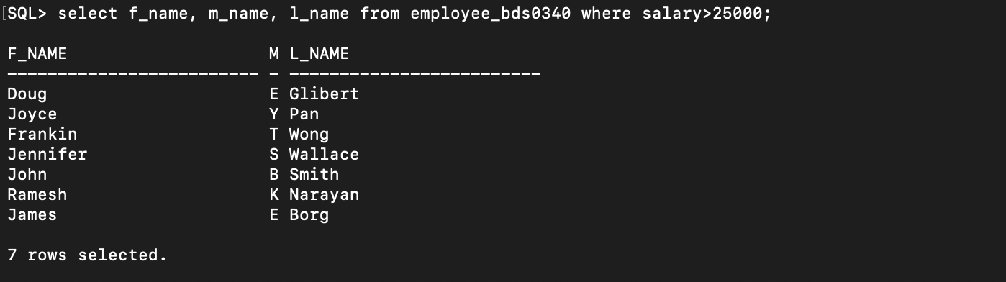

1. Find the employee names whose salary lies in the range between 30000 and 70000

Command:

select f_name, m_name, l_name from employee_bds0340 where salary > 30000 and salary < 70000;

Output:

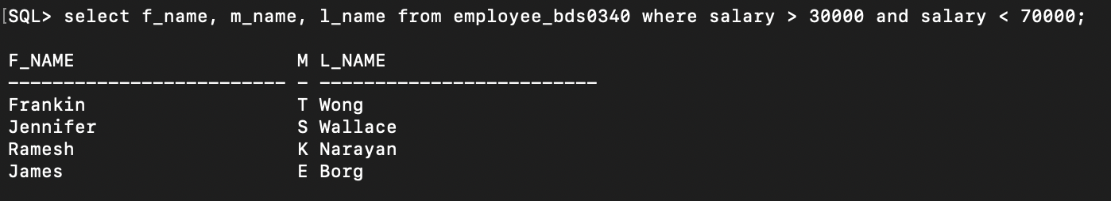

1. Find the employees who have no supervisor

Command:

select f_name, m_name, l_name from employee_bds0340 where super_ssn is null;

Output:

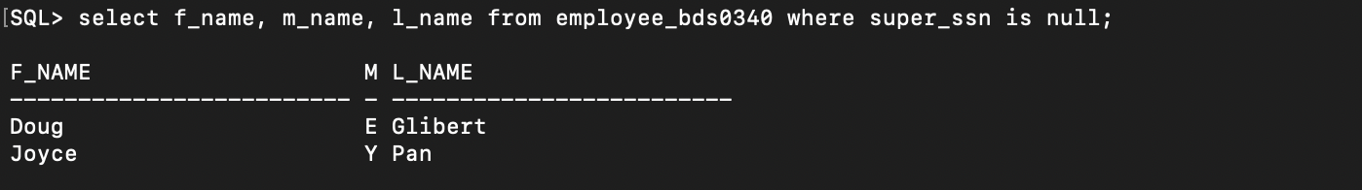

1. Display the birthday of all employees in the format DDth Month YYYY

Command:

select to_char(bday, 'DDth MON YYYY') from employee_bds0340;

Output:

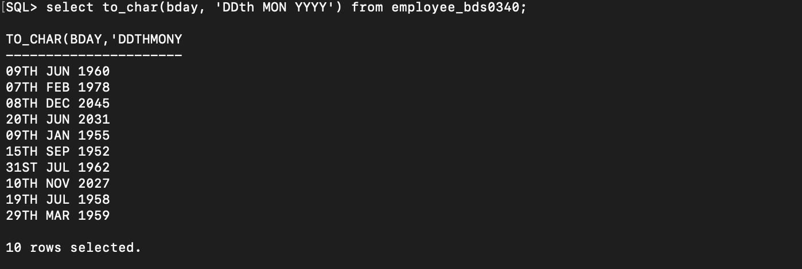

1. Display the employee names whose birthday is on or before 1978

Command:

select f_name, m_name, l_name from employee_bds0340 where bday < '1-JAN-1979';

Output:

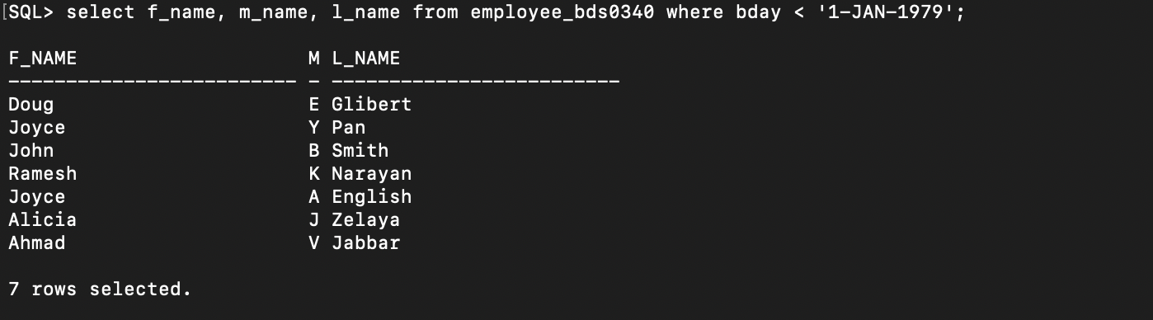

1. Display the employee names having ‘salt lake’ in their address

Command:

select f_name, m_name, l_name from employee_bds0340 where lower(address) like '%' || 'salt lake' || '%';

Output:

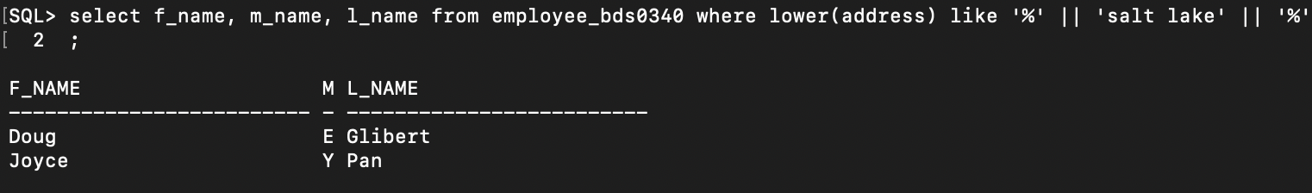

1. Display the department names that start with ‘M’

Command:

select name from department_bds0340 where name like 'M%';

Output:

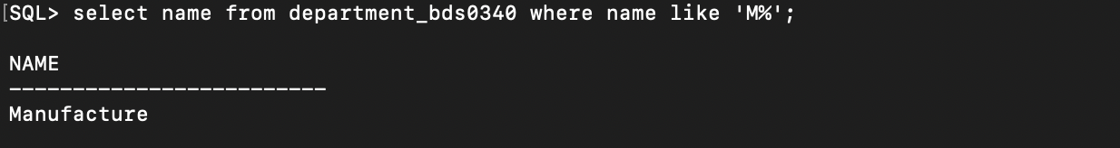

1. Display the department names that end with ‘E’

Command:

select name from department_bds0340 where name like '%e';

Output:

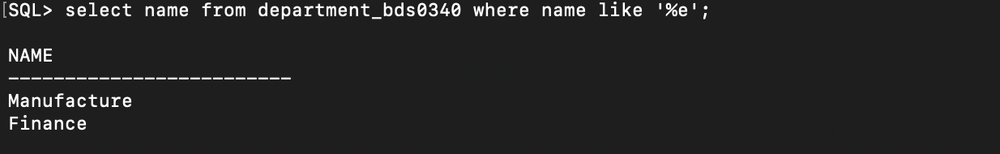

1. Display the names of all the employees having supervisor with any of the following ssn – 554433221, 333445555

Command:

select f_name, m_name, l_name from employee_bds0340 where super_ssn in (554433221, 3334455555);

Output:

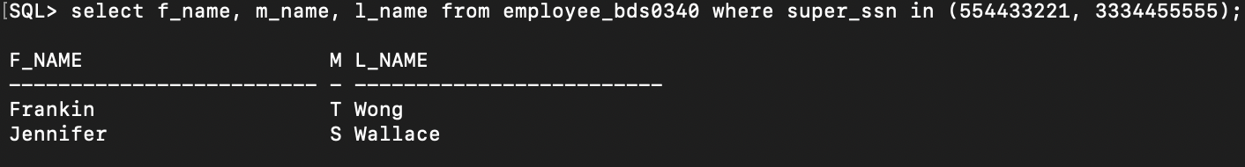

1. Display all the department names in upper and lower case

Command:

select lower(name), upper(name) from department_bds0340;

Output:

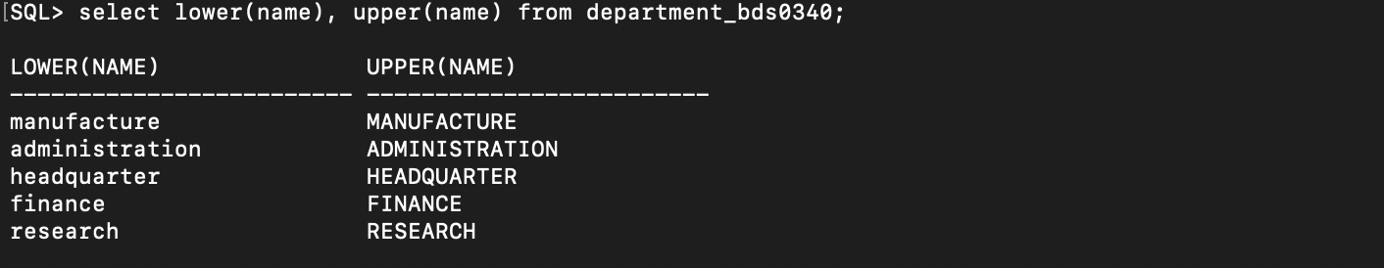

1. Display the first four characters and last four characters of the department names using ltrim and rtrim

Command:

select ltrim(substr(name, 0, 4)) from department_bds0340;

select rtrim(substr(name, -4)) from department_bds0340;

Output:

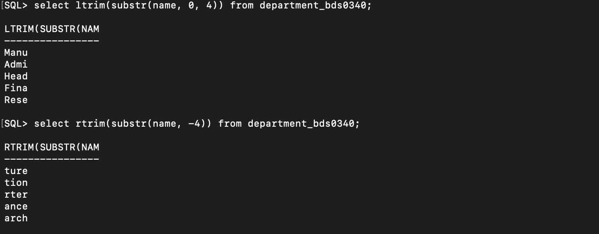

1. Display the substring of the address from 5th to 11th position of all employees

Command:

select substr(address, 5, 12) from employee_bds0340;

Output:

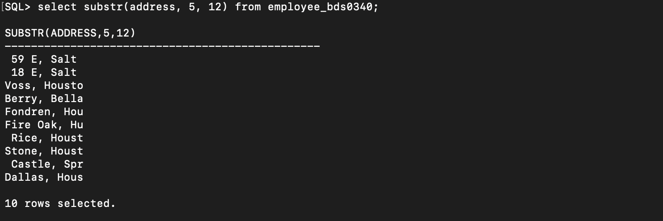

1. Display the manager start date on adding 3 months to it

Command:

select add_months(mgr_start_date, 3) from department_bds0340;

Output:

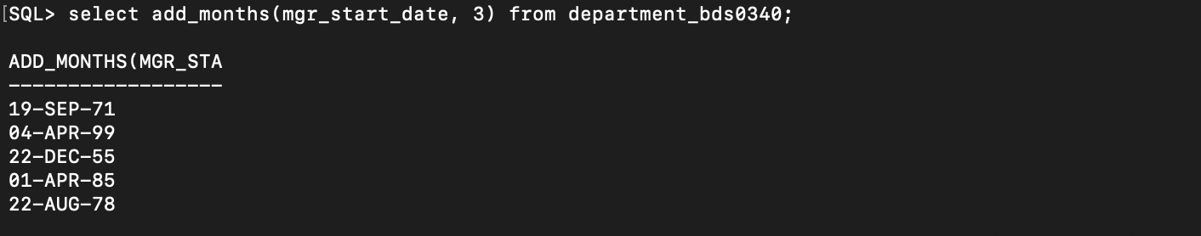

1. Display the age of all the employees rounded to 2 digits

Command:

select round((sysdate – bday) / 365, 2) from employee_bds0340;

Output:

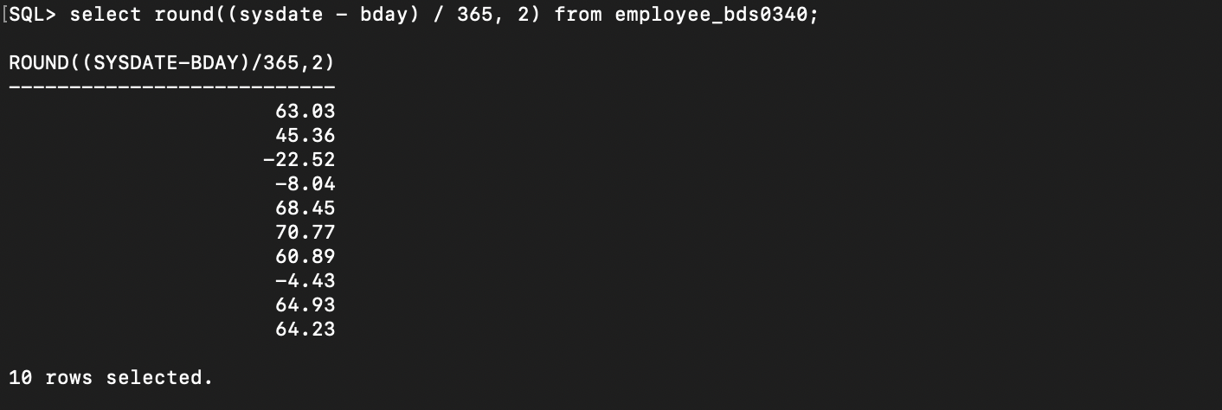

1. Find the last day and the next day of the month in which each manager has joined

Command:

select mgr_start_date - 1 as last_day, mgr_start_date + 1 as next_day from department_bds0340;

Output:

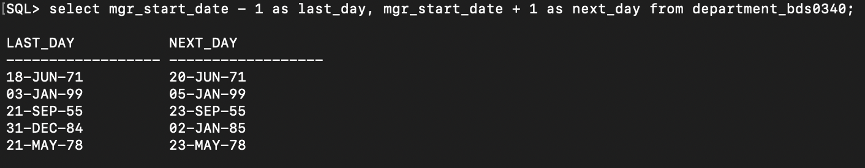

1. Print a substring from the string ‘Harini’

Command:

select substr('Harini', 0, 4) from dual;

Output:

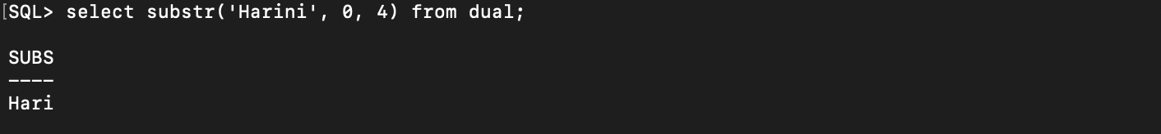

1. Replace the string ‘ni’ from ‘Harini’ by ‘sh’

Command:

select replace('Harini', 'ni', 'sh') from dual;

Output:

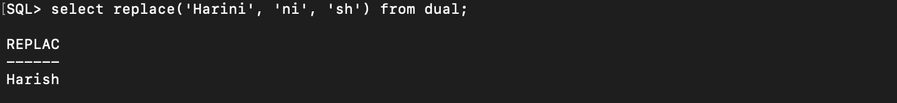

1. Print the length of all department names

Command:

select length(name) from department_bds0340;

Output:

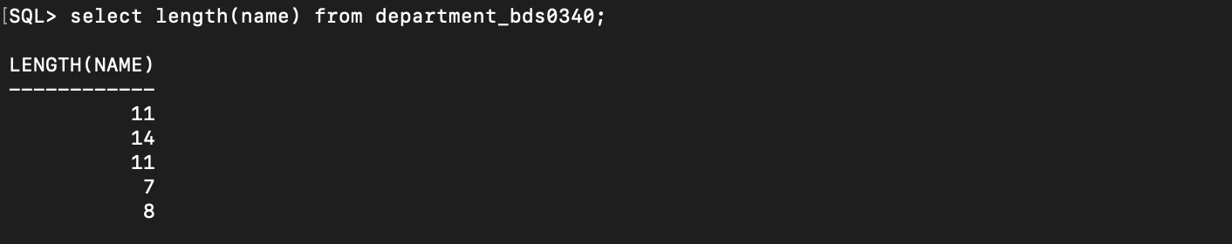

1. Print the system date in the format DDth MON YYYY

Command:

select to_char(sysdate, 'DDth MON YYYY') from dual;

Output:

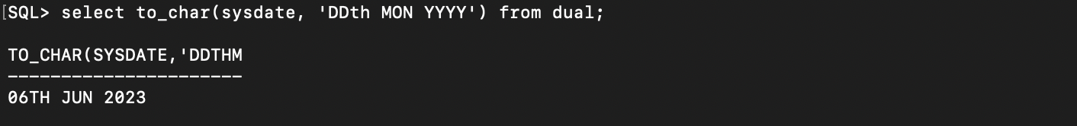

1. Display the date after 10 months from current date

Command:

select add_months(sysdate, 10) from dual;

Output:

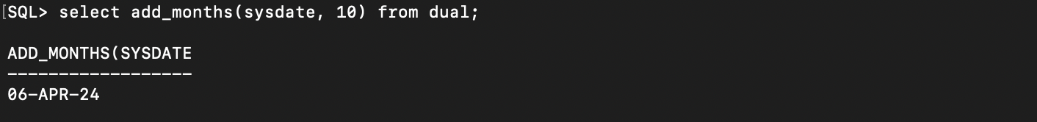

1. Display the next occurrence of Friday in this month

Command:

select next_day(sysdate, 'FRIDAY') from dual;

Output:

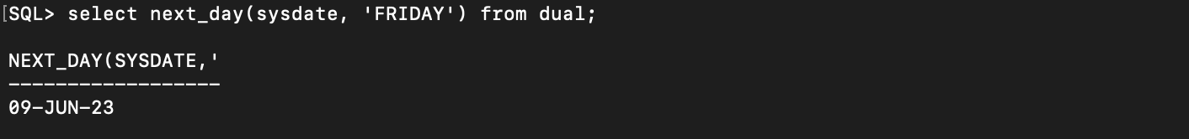

1. Convert ssn of an employee to number format and display

Command:

select ssn from employee_bds0340;

Output:

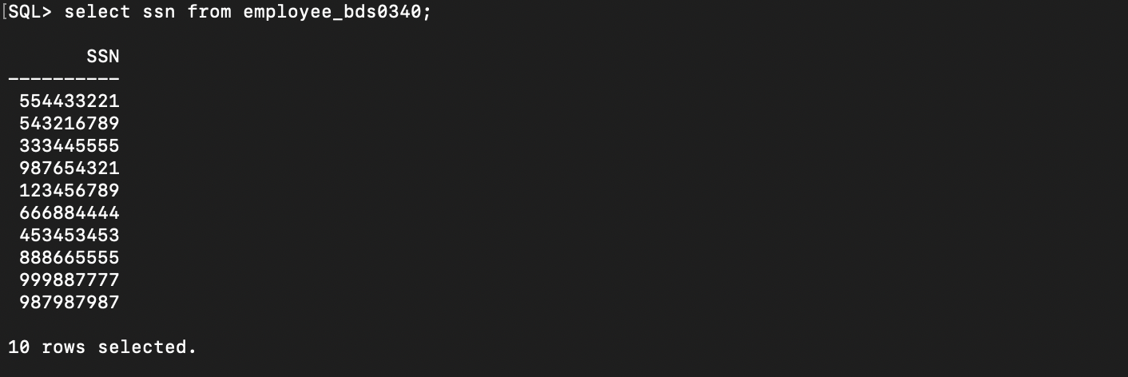

1. Display the project location padded with **** on left side

Command:

select concat('****', location) from project_bds0340;

Output:

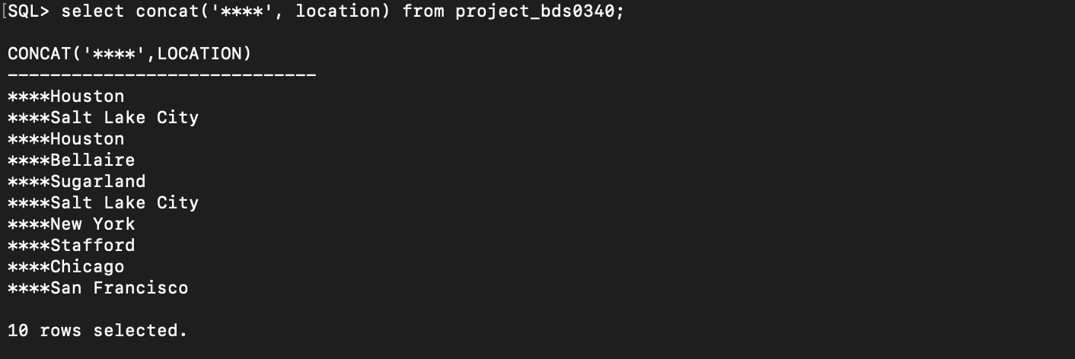

1. Remove the word ‘project’ from the project names and display it

Command:

select replace(name, 'project', '') from project_bds0340;

Output:

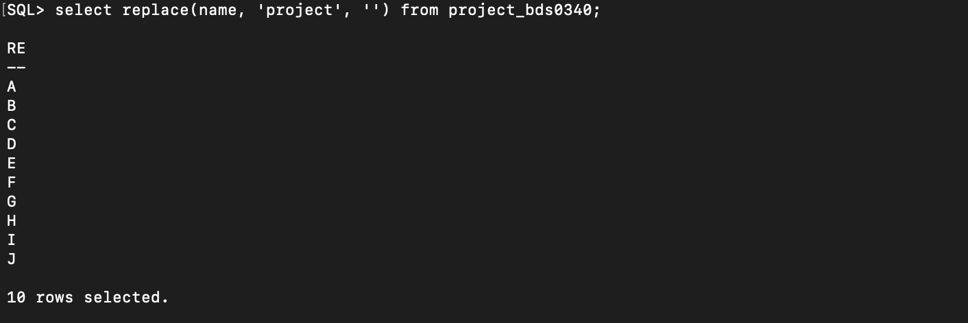

1. Select the ssn of the employee whose dependent name is Michael or Abner

Command:

select emp_ssn from dependent_bds0340 where name in ('Michael', 'Abner');

Output:

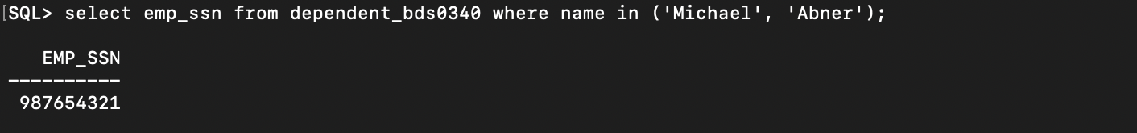

Exercise – IV

1. How many different departments are there in the ‘employee’ table

Command:

select distinct dept from employee_bds0340;

Output:

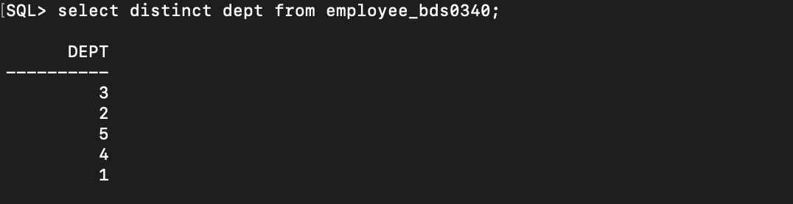

1. For each department display the minimum and maximum salaries

Command:

select dept, min(salary), max(salary) from employee_bds0340 group by dept;

Output:

1. Print the average annual salary

Command:

select avg(salary) from employee_bds0340;

Output:

1. Count the number of employees over age 30

Command:

select count(*) from employee_bds0340 where floor(months_between(sysdate, bday) / 12) >= 30;

Output:

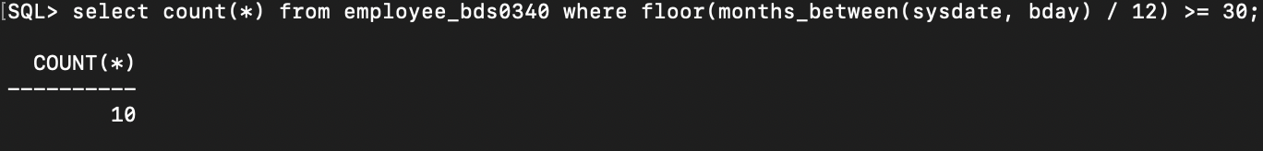

1. Print the department name and average salary of each department

Command:

select d.name, avg(e.salary) from employee_bds0340 e join department_bds0340 d on e.dept = d.num group by d.name;

Output:

1. Display the department name which contains more than 30 employees

Command:

select d.name from employee_bds0340 e join department_bds0340 d on e.dept = d.num group by d.name having count(*) >= 30;

Output:

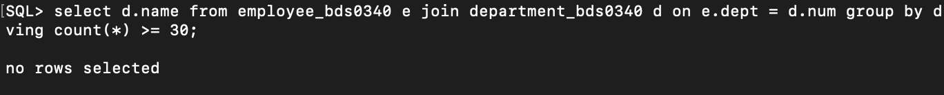

1. Calculate the average salary of employees by department and age

Command:

select d.name, floor(months_between(sysdate, e.bday) / 12) as age, avg(e.salary) from employee_bds0340 e join department_bds0340 d on e.dept = d.num group by d.name, floor(months_between(sysdate, e.bday) / 12);

Output:

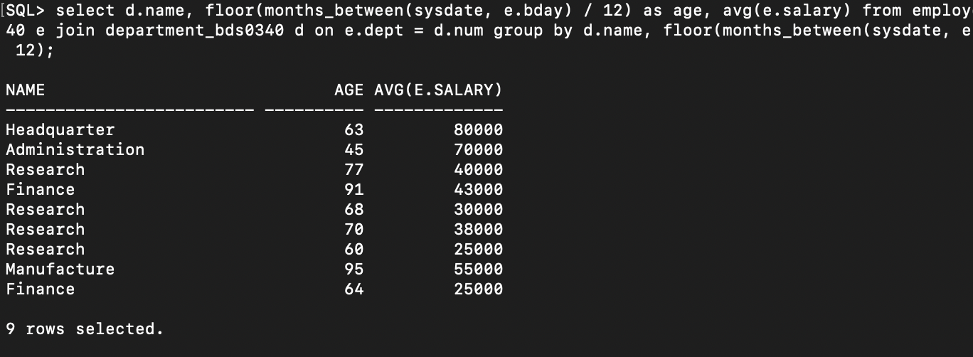

1. Count separately the number the number of employees in the research and finance department

Command:

select d.name, count(*) from employee_bds0340 e join department_bds0340 d on e.dept = d.num where d.name in ('Research', 'Finance') group by d.name;

Output:

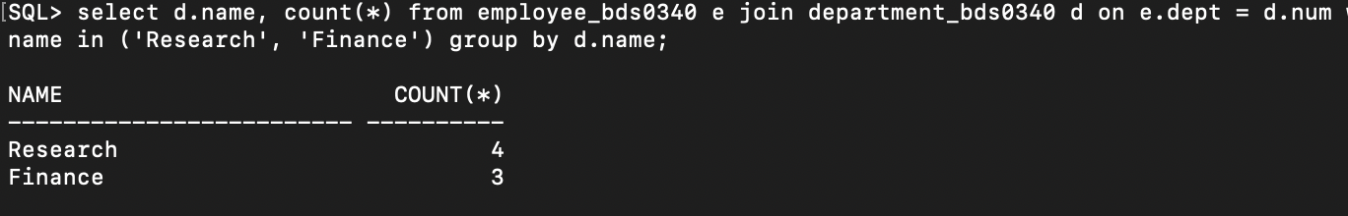

1. List out all the employees based on seniority

Command:

select l_name, m_name, l_name from employee_bds0340 order by months_between(sysdate, bday);

Output:

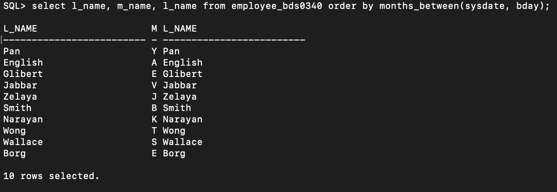

1. List out all the employees who works in manufacturing department and group by first name

Command:

select f_name from employee_bds0340 where dept = (select num from department_bds0340 where name = 'Manufacture') order by f_name;

Output:

